 

ESINF REPORT

**Group 118**

**NUNO BARBOSA – 1210822 KEVIN SOUSA-1180853 RODRIGO FERREIRA - 1191447 JOÃO MARTINS- 1201539**

**Subject: Estruturas de Informação (ESINF) Teacher: Nuno Filipe Teixeira Malheiro (NFM)**

**JANUARY 2022**

# Content

Introduction 3

Algorithm Analysis 4

US401 – Know which ports are more critical (have greater centrality) in this freight network. 5

US402 – know the shortest path between two locals (city and/or port) 6/7

US403 - Know the most efficient circuit that starts from a source location and visits the greatest number of other locations once, returning to the starting location and with the shortest total distance…………………………………………………………………………………………………………………………………………….8

Domain Model Diagram 8

Class Diagram ……………………………………………………………………………………………………………………….9

# Introduction

In the following report, we will present our User Story development as well as the respective Domain Model and Class Diagram for the whole project.

# Algorithm Analysis

For each User story, we will explain the code written, as well as the difficulties had while developing.

We also determine the time complexity for each method, according to the Big-O notation

## US401 – Know which ports are more critical (have greater centrality) in this freight network

**COMPLEXITY: (**O ($n^{3}$))

## US402 – Know the shortest path between two locals (city/port)

**Time Complexity:** O(n)

**Time Complexity:** O(n)

**

**TIME COMPLEXITY:** (O ($n^{3}$))

**US403 – Know the most efficient circuit that starts from a source location and visits the greatest number of other locations once, returning to the starting location and with the shortest total distance**

**Domain Model Diagram**

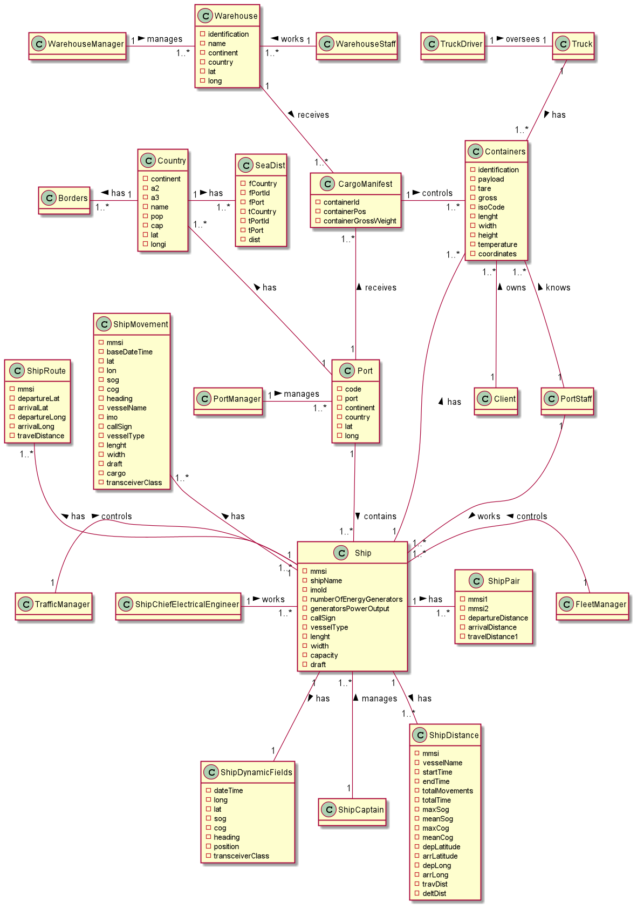

**Class Diagram**

